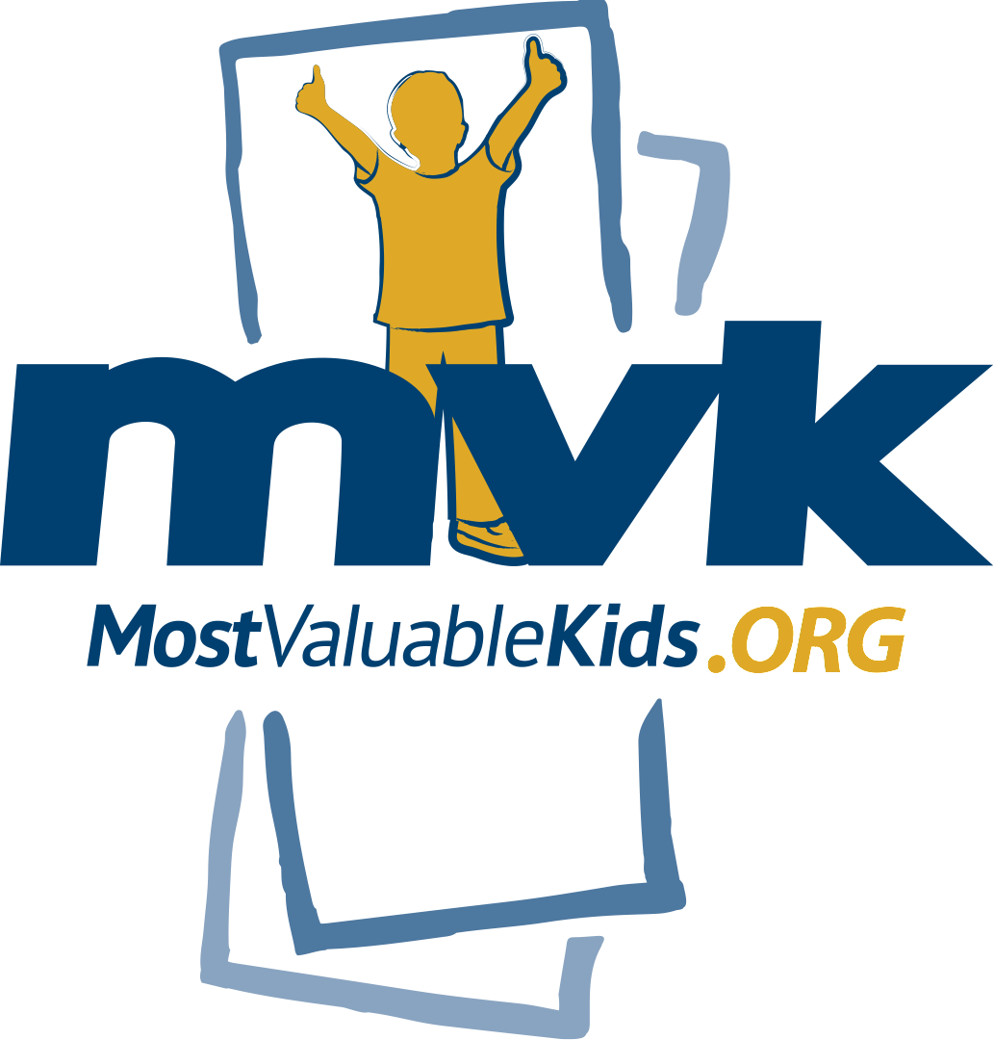

FOR IMMEDIATE RELEASE CONTACT: Tamie Sullivan, Girls with Pearls
tamie@mostvaluablekids.org
cell: 513-252-5565

Sherri Friedman, Most Valuable Kids
sherri@mostvaluablekids.org

GIRLS WITH PEARLS TO BECOME PROGRAM OF MOST VALUABLE KIDS

(May 17, 2018) — Girls grow into young women, and now Cincinnati’s Girls with Pearls program is growing too. Girls with Pearls (GWP), will officially become a program of Most Valuable Kids, announced Sherri Friedman, CEO of Most Valuable Kids, Cincinnati.
Girls with Pearls is an after-school girls program started by Tamie Sullivan, a small business owner and community activist, and Belinda Tubbs-Wallace, the principal at Rockdale Academy. The program is designed to keep a girl in school, help her dream big and empower her to plan for her future and the goals she wants to achieve in life.
The program is currently in four schools - Rockdale, Hughes, Cincinnati College Prep and Parker Woods. It is run by school staff and volunteers using the evidence-based SMART Girls Curriculum provided by Boys & Girls Clubs of America.
“Girls with Pearls is a wonderful program that closely aligns with our mission to encourage kids to dream big,” said Friedman. “We are excited to have Tamie join our MVK team as the GWP Executive Director to help us grow and expand the important mission of female empowerment.”

2/Girls with Pearls Joins Most Valuable Kids

“In a world where we are still striving to achieve gender equity, it’s clear that girls benefit from opportunities to bond and support each other while developing leadership skills and hearing from women that look like them,” said Sullivan.
With leadership from Sullivan and others, Girls with Pearls partnerships are growing too. Over the last two years, Girls with Pearls, Cincinnati has partnered with 84.51, where their associate resource group, Women’s EDGE, recently hosted more than 50 girls and their program leaders, gave them a tour of the cutting-edge workplace, taught them budgeting and shared their career stories. On Valentine’s Day, Most Valuable Kids coordinated an event at Sugar ‘n Spice, which brought all four GWP programs together for the first time to meet each other, eat pancakes and play games.
New school-based MVK Girls with Pearls clubs will be starting in the 2018-2019 school year. To learn more about starting Girls with Pearls or to find out how you can get involved, contact Tamie Sullivan at tamie@mostvaluablekids.org or visit www.mostvaluablekids.org/girlswithpearls.
Most Valuable Kids is a nonprofit agency that turns tickets and experiences into life-changing opportunities for underserved kids in our community. MVK creates extracurricular programs that reward hard work, strengthen relationships, enhance self-esteem and encourage kids to dream big! MVK currently serves more than 100,000 at-risk kids who participate in 90+ pre-screened non-profit agencies. These partner agencies, who support low-income and at-risk kids, use the donated tickets and experiences as rewards and incentives. For more information, visit our website at www.mostvaluablekids.org or like us on Facebook at Most Valuable Kids of Greater Cincinnati.
###

